**Project Design Phase-II**

**Data Flow Diagram & User Stories**

|  |  |
| --- | --- |
| **Date** | **31-10-22** |
| **Team ID** | **PNT2022MID12291** |
| **Project Name** | **Smart Farmer-IOT Enabled Smart Farming Application** |
| **Maximum marks** | **4 MARKS** |

**Data Flow Diagrams:**

A Data Flow Diagram (DFD) is a traditional visual representation of the information flows within a system. A neat and clear DFD can depict the right amount of the system requirement graphically. It shows how data enters and leaves the system, what changes the information, and where data is stored.

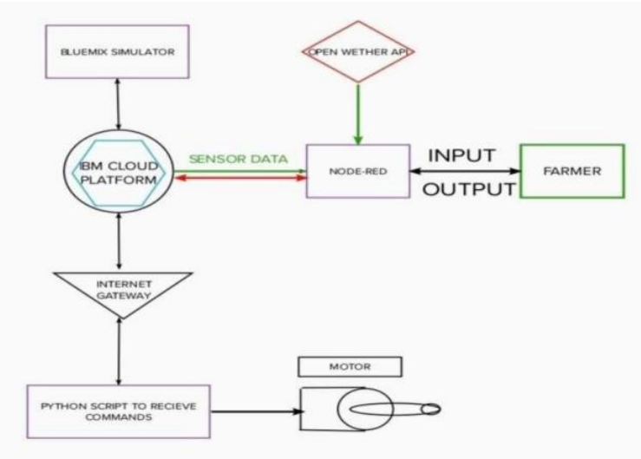

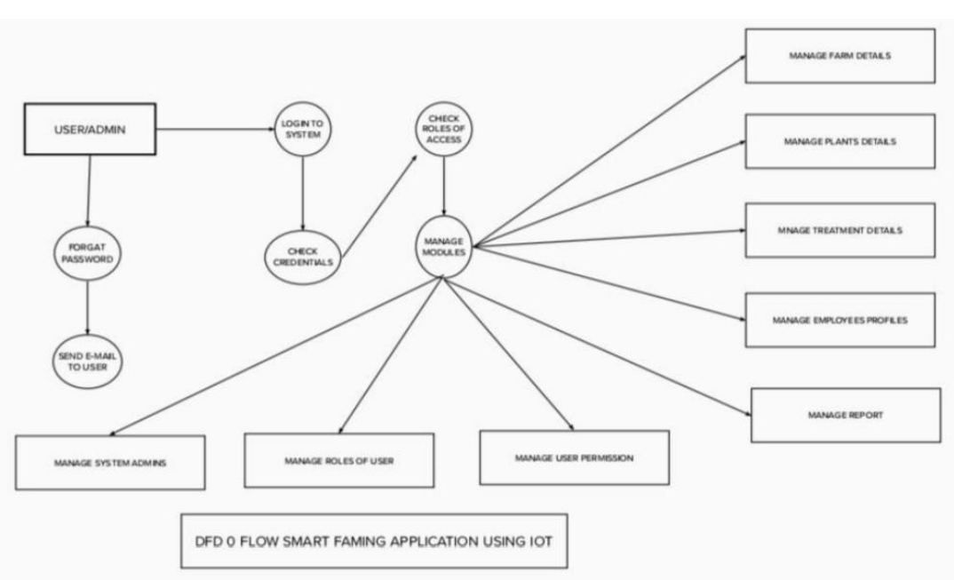

1. The different soil parameters temperature, soil moistures and then humidity are sensed using different sensors and obtained value is stored in the Ibm cloud.
2. Arduino UNO is used as a processing Unit that process the data obtained from the sensors and whether data from the weather API.
3. NODE-RED is used as a programming tool to write the hardware, software and APIs. The MQTT protocol is followed for the communication.
4. All the collected data are provided to the user through a mobile application that was developed using the MIT app inventor. The user could make a decision through an app, weather to water the crop or not depending upon the sensor values. By using the app they can remotely operate to the motor switch.

**User Stories**

Use the below template to list all the user stories for the product.

|  |  |  |  |  |  |  |
| --- | --- | --- | --- | --- | --- | --- |
| **User type** | **Functional Requirement (Epic)** | **User Story Number** | **User Story / Task** | **Acceptance criteria** | **Priority** | **Release** |
| Customer (Mobile user) | Registration | USN-1 | As a user, I can register for the application by entering my email, password, and confirming my password. | I can access my account / dashboard | High | Sprint-1 |
| Customer (Web user) | Dashboard | USN-2 | As a user, I will receive confirmation email once I have registered for the application | I can receive confirmation email & click confirm | High | Sprint-1 |
|  | Registration | USN-3 | As a user, I can register for the application through Facebook |  | Low | Sprint-2 |
|  |  | USN-4 | As a user, I can register for the application through Gmail |  | Medium | Sprint-1 |
|  | Login | USN-5 | As a user, I can log into the application by entering email & password |  | High | Sprint-1 |
|  | Dashboard |  |  |  |  |  |
| Customer (Web user) |  |  |  |  |  |  |
| Customer Care Executive | Help | USN-1 | As a user, if I have any queries or issues , I can reach out to the Support team | I will receive a reply from the support team that my message is accepted and later my queries or issues will be resolved | Medium | Sprint-3 |
| Administrator | Management | USN-1 | As a user, I need the resource management team to use quality products at the reasonable price | I get a warranty card and details about the product | Medium | Sprint-4 |
|  |  | USN-2 | As a user , if I didn’t receive a quality product ,I want a refund. | I can receive a free service or a change of product | Medium | Sprint-4 |